COLLEGE PROJECT REPORT
RANDOM NUMBER
GUESSING GAME
Using C Programming Language
A CASE-STUDY-BASED PROJECT
Submitted in partial fulfilment of the academic requirements for
Bachelor of Computer Applications (BCA (DATA SCIENCE))
Student Name: Yanish
Class / Section: 26BCD-4(B)
UID: 26BCD10333
Subject: C Programming
Academic Session: 2026–2027
Submitted To: MIS. KAMALDEEP KAUR
College / University: UIC
DEPARTMENT OF COMPUTER APPLIC

TABLE OF CONTENTS
1. Introduction and Case Study
2. Problem Statement and Objectives
3. Requirements and C Concepts
4. Working and Algorithm
5. Flowchart
6. Complete C Source Code
7. Code Explanation and Sample Output
8. Testing, Conclusion and References

1. INTRODUCTION
C is a general-purpose procedural programming language used to learn core programming concepts such as variables, data types, operators, decision-making and loops. This project is a simple console-based game developed entirely in C.
Case Study: In a classroom activity, one person selects a number and another person tries to guess it using “higher” or “lower” clues. In this project, the computer selects a secret number from 1 to 100. The player enters guesses, and the program gives a hint until the correct number is found.

2. PROBLEM STATEMENT
Develop a beginner-friendly C program that generates a random integer from 1 to 100, accepts guesses from the user, compares each valid guess with the secret number, displays a suitable hint and counts valid attempts. The game ends when the correct number is guessed.

2.1 OBJECTIVES
- Practise C header files, variables and input/output functions.
- Use rand(), srand() and time() to generate a pseudo-random number.
- Apply if-else statements and a do-while loop.
- Count attempts and validate the permitted number range.
- Understand how an algorithm and flowchart are converted into a C program.

3. SOFTWARE AND HARDWARE REQUIREMENTS
Type | Requirement
Software | C compiler such as GCC or Clang; Code::Blocks, VS Code or another editor; Windows, Linux or macOS.
Headers | stdio.h, stdlib.h and time.h.
Hardware | Desktop/laptop, keyboard, display and a basic processor with sufficient memory to run the compiler.

3.1 PROGRAMMING CONCEPTS USED IN C
- stdio.h: provides printf() and scanf() for input and output.
- stdlib.h: provides rand() and srand() for pseudo-random number generation.
- time.h: provides time(), used to create a changing seed.
- Variables: int variables store the secret number, guess and attempt count.
- Decision-making: if, else if and else compare the guess with the secret number.
- Loop: do-while repeats the game until the correct guess is entered.
- Operators: %, <, >, ==, || and ++ perform remainder, comparison, logical OR and increment operations.

4. WORKING OF THE PROJECT
- Initialize the random generator using srand((unsigned int)time(NULL)).
- Generate and store a secret number from 1 to 100.
- Set the attempt counter to zero and display instructions.
- Read a guess. Reject values outside 1–100.
- For a valid guess, increase the attempt counter.
- Display “Too low” or “Too high”; if correct, display congratulations and attempts.
- Repeat until the correct number is guessed.

4.1 ALGORITHM
START → Initialize random seed → Generate secret number → Set attempts to 0 → Read guess → Check range → Compare guess with secret number → Give low/high hint or success message → Repeat if incorrect → END.
Range calculation: rand() % 100 + 1. The remainder is from 0 to 99; adding 1 produces a value from 1 to 100.

5. FLOWCHART
The flowchart shows the main steps and decisions used by the C program. The first decision checks whether the guess is within the permitted range. The second decision checks whether it matches the secret number.
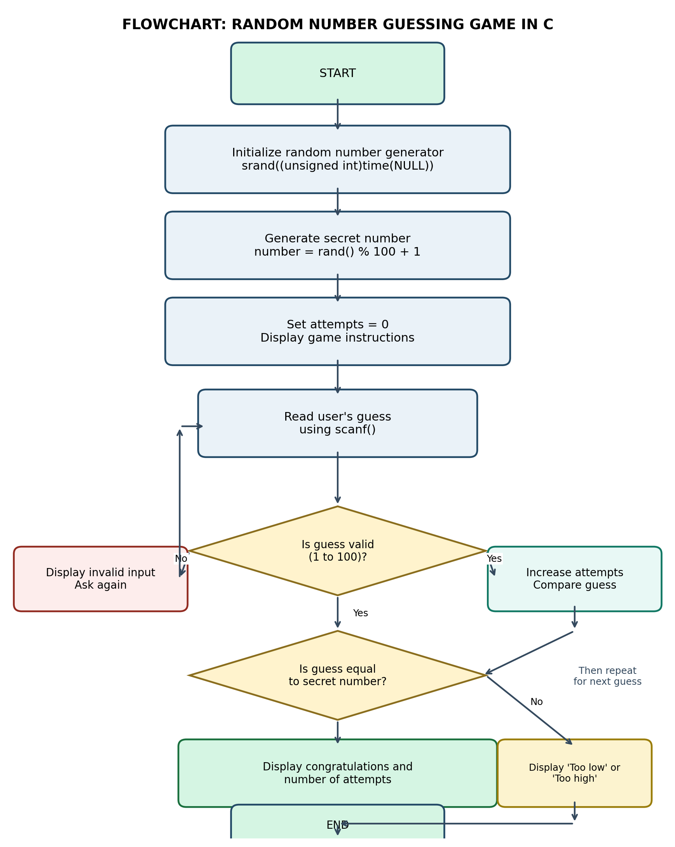
Figure 1: Flowchart of Random Number Guessing Game

6. COMPLETE C SOURCE CODE
Save the following program as guessing_game.c. It uses C language syntax only.
#include <stdio.h>
#include <stdlib.h>
#include <time.h>

int main(void)
{
int secretNumber, guess, attempts = 0;

srand((unsigned int)time(NULL));
secretNumber = rand() % 100 + 1;

printf("RANDOM NUMBER GUESSING GAME\n");
printf("I have selected a number from 1 to 100.\n");

do
{
printf("\nEnter your guess (1-100): ");

if (scanf("%d", &guess) != 1)
{
printf("Invalid input. Enter an integer.\n");
return 1;
}

if (guess < 1 || guess > 100)
{
printf("Please enter a number between 1 and 100.\n");
}
else
{
attempts++;

if (guess < secretNumber)
printf("Too low. Try a higher number.\n");
else if (guess > secretNumber)
printf("Too high. Try a lower number.\n");
else
{
printf("Congratulations! You guessed it.\n");
printf("Valid attempts: %d\n", attempts);
}
}
} while (guess != secretNumber);

return 0;
}

7. EXPLANATION OF THE C CODE

Header files
stdio.h supports printf() and scanf(); stdlib.h supports rand() and srand(); time.h supports time().

main() and variables
Execution starts from main(). secretNumber stores the computer's number, guess stores user input and attempts counts valid guesses.

Random number
srand((unsigned int)time(NULL)) seeds the random generator. rand() % 100 + 1 generates a number from 1 to 100.

Input and validation
scanf("%d", &guess) reads an integer. Its return value is checked. The condition guess < 1 || guess > 100 rejects out-of-range values.

Loop and comparison
The do-while loop repeats. if-else compares the guess: lower gives “Too low”, higher gives “Too high”, and equality ends the game.

Attempt count and exit
attempts++ counts valid guesses only. return 0 indicates normal completion.

7.1 SAMPLE OUTPUT
Illustrative run (assume the computer selected 42):
RANDOM NUMBER GUESSING GAME
I have selected a number from 1 to 100.

Enter your guess (1-100): 25
Too low. Try a higher number.

Enter your guess (1-100): 70
Too high. Try a lower number.

Enter your guess (1-100): 110
Please enter a number between 1 and 100.

Enter your guess (1-100): 42
Congratulations! You guessed it.
Valid attempts: 3

8. TESTING AND RESULTS
For testing, assume the secret number is 42. The expected behaviour is shown below.
Input | Test condition | Expected result | Status
25 | Below secret | Too low | Pass
70 | Above secret | Too high | Pass
42 | Correct guess | Success message | Pass
0 / 101 | Out of range | Range warning | Pass
abc | Non-integer | Error message and safe exit | Pass
Result: The program gives appropriate hints, accepts the correct number, rejects out-of-range values and counts only valid guesses.

8.1 ADVANTAGES
- Easy for beginners to understand.
- Practises important C concepts in one program.
- Lightweight and needs no internet, database or external library.
- Interactive and gives immediate feedback.

8.2 LIMITATIONS
- One player and one round per execution.
- Fixed number range and no difficulty levels.
- Non-integer input ends the program.
- rand() is pseudo-random and not suitable for security use.

8.3 FUTURE SCOPE
- Add difficulty levels and a maximum attempt limit.
- Allow replay and multiple rounds.
- Add a score or high-score file using C file handling.
- Improve input validation and divide code into functions.

8.4 CONCLUSION
The Random Number Guessing Game was developed using C. It demonstrates variables, standard header files, input/output, pseudo-random number generation, conditions and loops. The project converts a simple problem into an algorithm, flowchart and working program, helping a BCA beginner practise logical thinking and basic programming.

REFERENCES
- Brian W. Kernighan and Dennis M. Ritchie, The C Programming Language, 2nd Edition, Prentice Hall.
- E. Balagurusamy, Programming in ANSI C, McGraw Hill Education.
- GCC Documentation: https://gcc.gnu.org/onlinedocs/
- cppreference, C language reference: https://en.cppreference.com/w/c
Compilation (GCC): gcc guessing_game.c -o guessing_game. Run ./guessing_game on Linux/macOS or guessing_game.exe on Windows.

